Kheelona Positioning Strategy
Oct 8, 2026 · @NG

The recommendation
Lead with brain development, and win on how Kheelu does it: conversation. Brain development is what Indian parents of young children already shop for, and it is a promise worth paying ₹4,999 for. But on its own the phrase is not ownable. ₹99 activity books and ₹400 puzzles already claim it, and "brain" claims in India carry a credibility problem. Kheelona wins the category by being specific about the mechanism: Kheelu asks, your child thinks.
That mechanism also answers the newest fear parents have about AI. In May 2026 Brookings warned of "cognitive stunting": children letting AI do their thinking. Most AI gives children answers. Kheelu is built to give them questions.
Category: the brain-development toy that talks.
Positioning statement: For Indian parents of 4 to 7 year olds who want to support their child's growing brain without more screens, Kheelu is the brain-development toy that talks: a soft, screen-free AI rabbit that builds four thinking skills (words, reasons, stories and questions) through everyday conversation, in English and the family's own language. Unlike puzzles and activity books, it talks with your child and grows with them every day. Unlike AI that hands children answers, Kheelu asks back, so your child does the thinking. And parents see the growth in a simple weekly report.
Master line: It asks. They think.
Hero line for the website: "Kheelu helps your child's brain grow, one conversation at a time."
What this means in practice
- Brain development is the promise. Conversation is the proof of how. Screen-free and safe are the foundation.
- Give parents a simple model they can repeat: four thinking skills: Words, Reasons, Stories, Questions. Every feature, ad and report maps to one of them.
- "AI" stays, but as the engine, not the headline. The noun is "brain-development toy", not "AI toy".
- Every brain claim is worded so it can be backed up ("built to support", not "boosts"), signed off by the child-development advisor, and never uses fear.
- Market to ages 4 to 7. One product, one promise; Kheelona OS stays in the investor deck.
- It only works if the product does it: Kheelu must end most turns with a question, and the parent app must report the four skills. Both need product sign-off this week.

USE BRAIN DEVELOPMENT IN THESE CONDITIONS
Condition | Why
Always say how: through conversation, and Kheelu asks your child questions | "Brain development" alone puts Kheelu next to ₹99 activity books and ₹400 puzzles that use the same words. The mechanism is what makes it ownable and believable.
Every brain claim must be backed up, and never use fear | ASCI requires claims to be substantiated and says education ads must not play on "parental or student anxieties". "Brain" claims also carry baggage in India from pseudoscience such as "midbrain activation" classes.
Answer the AI fear head on | Parents increasingly worry AI will do their child's thinking for them (Brookings, May 2026). An AI brain-development toy has to say plainly: Kheelu doesn't think for your child, it makes them think.
What to keep from the research
- Parents buy learning, not friendship: 70% want an AI toy to help their child learn, 19% want a companion and 56% reject companionship. Brain development fits this exactly.
- Never sell "AI best friend". Borrow warmth, never sell friendship.
- Indian parents fear the screen more than AI.
- Trust is the ceiling of the category, so safety has to be visible and specific.
- Design for Day 90, not Day 1, and never cloud-brick the toy.
Where I depart from the research
Research says | I recommend | Why
Core age 6 to 8; exclude under 4 | Market to 4 to 7. Sell to 3-year-olds only "with a grown-up nearby" and never show them alone in ads | Kheelu is a soft rabbit, which 7 to 8 year olds will find babyish, and the pilot children are younger. The two strongest studies behind the brain claim used 4 to 6 year olds (Romeo, 2018) and preschoolers (Xu, 2022). NEP 2020 also puts the foundational years at 3 to 8. I keep the caution: speech recognition is weaker under 4, and safety groups draw a line at 5.
Frame Kheelu as a tutor or teacher | Frame it as brain development through conversation | "Tutor" pulls Kheelu into edtech, which carries Indian parents' distrust and ASCI's education rules, and puts pressure on a 4-year-old.
Win on being "demonstrably safe, screen-free, learning-first" | Safety and screen-free are the foundation; brain development is the position | Every Indian rival now says screen-free and safe. The v9 competitor review notes "No screen does not separate Kheelu".
Position against Miko on price | Price against what parents already spend on their child's mind | Few parents choose between a ₹13,999 robot and a rabbit. At ₹7,999 after launch Kheelu also costs more than MyWonder (₹5,499) and Pookie (₹6,999), so "cheaper" can't last. Anchor against enrichment spend instead (section 7).
What I remove from the deck
Deck says | Change to | Why
"Maps your emotions and triggers in long-term memory"; "remembers your life events, values, emotions" | "Remembers what your child has learnt and loves, so tomorrow builds on today" | Reads as surveillance, and is close to the tracking of children India's DPDP Act restricts. Brain development needs learning progress, not emotion profiles.
Mission: "safe, conversational AI tutors… combining robotics" | Rewrite (section 5) | Describes the technology, not what changes in the child
"A range of devices… AI toys, wearables and robots", Kheelona OS | Investors only | A new brand can carry one product and one promise

The market as it stands in October 2026
Indian parents already shop for brain development. The shelf is crowded at the cheap end, the claims carry scrutiny, and AI has just added a new worry. That combination is the opening.
Parents are primed for "the early years build the brain"
- India's National Education Policy 2020 states that over 85% of a child's brain develops by age 6, and sets the foundational years at 3 to 8. (EducationWorld on NEP 2020) Schools and preschools now repeat this to parents.
- The research brief found 70% of parents want an AI toy to help their child learn, the top reason to buy.
- Indian children under 5 average about 2.2 hours of screen time a day, roughly double the guideline (AIIMS Raipur meta-analysis via Pune Pulse, Jan 2026). Parents want a better use of that time.
The "brain development" shelf is crowded, cheap and hands-only. Search "brain development toys" in India and you get puzzles, tangrams and activity books at ₹99 to ₹429 (MagicDrop buying guide, Jul 2026). They build hand skills and focus. None of them talks with a child, and none shows a parent progress. Kheelu should join this shelf and stand apart on it.
The AI rivals sell friendship, not thinking. Their own pages:
Brand | How it describes itself | Price
Miko Mini | "AI-powered conversational robot", "a cherished companion", STEAM learning | ₹13,999
MyWonder | "Learn From Safe & Intelligent AI Companions" | ₹5,499
Pookie (Scoobies) | A friend-like companion that understands moods | ₹6,999
MyWonder comes closest, with "Speak, Listen, Learn". But it still leads with "AI companions". Nobody owns brain development through conversation.
Three forces Kheelona must manage
- AI's new fear: "cognitive stunting". Brookings (May 2026) warns that heavy AI use lets children skip the effortful thinking that builds their minds: "children must learn to think before they learn to prompt." (Brookings) An AI toy promising brain growth will be asked about this. Kheelu's answer is its design: it asks, the child thinks.
- The backlash against AI companions. Common Sense Media (Jan 2026) advised against AI companion toys for children 5 and under, mainly over attachment (KQED). California banned companion-chatbot toys for under-16s from 2027 (Toy Association). A brain-development framing keeps Kheelu clear of that label.
- Scrutiny of claims. ASCI requires claims to be substantiated, and its education guidelines bar ads that play on "parental or student anxieties" or create fear of missing out (ASCI, Mar 2023). Parents have also seen "brain" pseudoscience: "midbrain activation" classes have been exposed by rationalists for years (Wikipedia). Vague brain promises will be read as hype.

The science, and what Kheelu can honestly claim
The evidence supports one clear idea: young children's brains grow through back-and-forth conversation in which the child does real thinking. That is what Kheelu should be built and sold around. Here is how it turns into four skills parents can see.
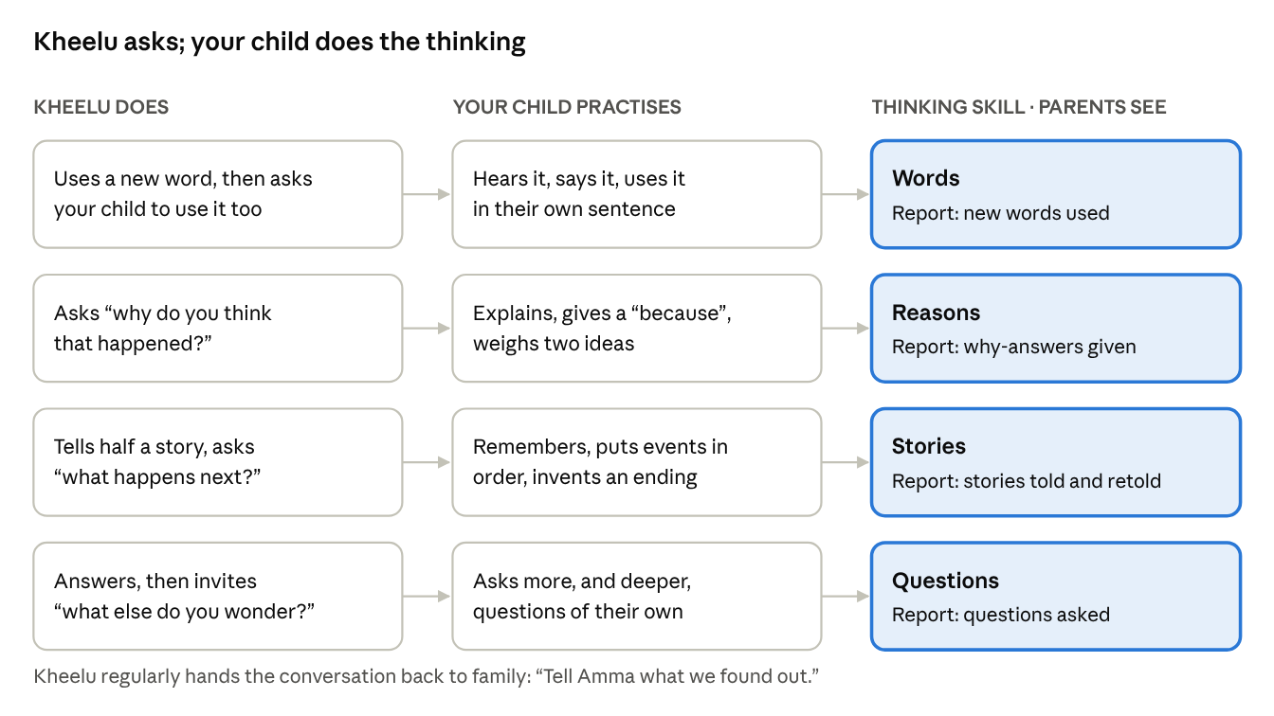
How conversation builds the four thinking skills · 4 skills
The four skills map onto what NEP 2020 asks the early years to build (cognitive development, early language, communication) in words a parent can repeat.
What the evidence says
Finding | Source | How strong | How Kheelona uses it
Back-and-forth "serve and return" exchanges build and strengthen neural connections, and support early language and later higher-level thinking | Harvard Center on the Developing Child | Strong, but about caring adults | The idea Kheelu is built around, never "Harvard-proven"
In 4 to 6 year olds, the number of conversational turns, not words heard, predicted language scores and activity in Broca's area | Romeo et al. 2018, Psychological Science | Strong, but correlational and with adults | Why Kheelu asks back: turns, not talk, matter
Children who talked with an AI that asked questions during a story understood it better and learnt more words than children who only listened, in some cases as much as with a human partner | Xu et al. 2022, Child Development, via Ying Xu (Harvard) | Good: direct evidence for AI that asks | The closest evidence for Kheelu's design. Can be cited.
The same research found children lead conversations and add their own ideas more with people than with AI | Same as above | Good | Why Kheelu hands the conversation back to family
Preschoolers ask about 76 information-seeking questions an hour, and the act of asking is linked to how they think | Lazaroff & Vlach 2022 | Moderate | The "Questions" skill and the "why" years insight
Over-reliance on AI lets children skip effortful thinking ("cognitive stunting") | Brookings, May 2026 | Early evidence, widely reported | The risk Kheelu's design answers
What Kheelu can claim today, and what it can't yet
- Can claim: Kheelu is built around back-and-forth conversation, which research links to young children's language and brain development. It asks your child questions so they do the thinking.
- Can claim after advisor sign-off: "Helps your child's brain grow."
- Can claim only with pilot data: any result, such as "children learnt X new words" or "answered X questions a session".
- Cannot claim: that Kheelu itself has been proven to grow the brain, raise IQ or match a parent.

The category to refuse, and the one to own
Kheelona should stand on the brain-development shelf parents already know, as the only toy on it that talks. A category is the shelf a parent puts you on in their head. The right shelf decides what you are compared with.
Refuse
- AI toy. Compared on tech, priced against ₹1,599 "ChatGPT robots", blamed for every scandal.
- AI companion. The label regulators and safety groups now target.
- Edtech or tutor. Compared with apps and classes, under ASCI's education rules and Indian parents' edtech distrust.
Own: the brain-development toy that talks. Why this works:
- Parents already shop on this shelf and know what it means. No new category to explain.
- On that shelf, Kheelu is the only product that talks with the child, grows with them and shows progress. That justifies ₹4,999 next to ₹400 puzzles.
- It matches Kheelona's own vision of "sharper minds", and the research finding that parents buy learning, not friendship.
- It turns AI from a fear into a reason: the AI is what lets the toy ask questions back.
- It outlives Kheelu. Future products can all be brain-development products that talk.
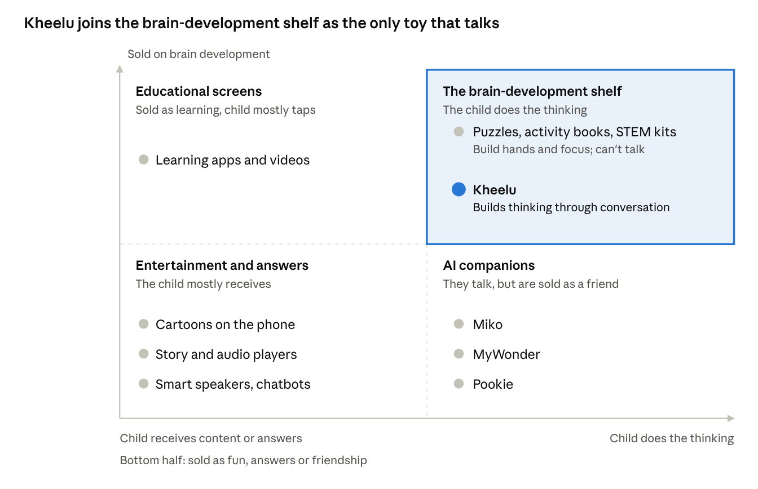
Category map · how the child engages vs what the product is sold on
The map places each brand by the words on its own site, not by testing. Puzzles and Kheelu share the top-right shelf; only Kheelu builds thinking through talk.
Brand foundations, updated
Level | Current | Recommendation
Vision | To build sharper minds and bigger smiles for kids everywhere. | Keep. It already says "sharper minds".
Purpose | To make learning, curiosity, and meaningful conversation a natural part of childhood. | Keep. It holds both the promise (learning, curiosity) and the mechanism (conversation).
Mission | We build safe, conversational AI tutors for kids, combining robotics, great content, and play. | We make safe, screen-free toys that build young minds through conversation.
Positioning | (none) | The brain-development toy that talks. It asks. They think.

Who it's for
The first 500 buyers are urban parents, mostly mothers, of a 4 to 7 year old, who already spend time and money on their child's development and want a better use of screen minutes. Start in Bengaluru.
Role | Who | What they need to believe
Buyer | Mother, 28 to 40, English plus a home language, already buys books, puzzles or enrichment classes | "This builds my child's thinking, and I'll be able to see it."
User | Child, 4 to 7, in the "why?" years | "It's fun, and it wants to hear what I think."
Influencer | Father, grandparents, preschool teacher | "It's serious about learning, and it's safe."
Gift buyer | Relatives, corporate HR (Diwali, Christmas) | "A gift that's good for the child's mind, not another gadget."
The jobs Kheelu is hired for
- Grow my child's mind in the years that matter most. "I keep hearing these years build the brain. I want to do something real about it, without pushing a 5-year-old into classes."
- Make my child think, not just watch. "My child asks a hundred questions, then sits in front of cartoons. I want those questions answered and turned into more thinking." Preschoolers ask about 76 information-seeking questions an hour (Chouinard 2007, cited in Lazaroff & Vlach 2022). Kheelu is built for that energy.
- The 20-minute swap. "When I'm cooking or on a call, give my child something good for their brain instead of the phone." This is the everyday use, and the reason it gets used on Day 90.
Who it is not for (yet): children under 3; children 8 and over; and families looking for help with a diagnosed speech or developmental condition. Kheelu is not a therapy device, and we never market it as one.

Positioning statement and the alternatives it beats
This statement is internal. Every ad, script, caption and website line gets checked against it.
Part | Kheelu
For | Indian parents of 4 to 7 year olds
Who | want to support their child's growing brain, without more screens
Kheelu is | the brain-development toy that talks: a soft, screen-free AI rabbit
That | builds four thinking skills (words, reasons, stories and questions) through everyday conversation, in English and the family's language
Unlike | puzzles and activity books, which can't talk or grow with the child; and AI that gives children answers or tries to be their friend
Because | Kheelu asks back, so your child does the thinking; it brings the family into the conversation; and parents see the growth in a weekly report, compared only with their child's own past
What parents compare Kheelu with. These are the real alternatives for the same money and the same minutes.
What parents do today | What they get | Where it falls short | What Kheelu says
Puzzles, activity books, STEM kits | Cheap, hands-on, "brain development" on the box | Can't talk, ask or explain; no progress to see | "Puzzles build hands. Conversation builds thinking."
Enrichment classes (phonics, abacus, early learning) | Structure, a teacher | Fixed time, travel, pressure, recurring fees | "Every day at home, at your child's pace."
Learning apps and videos | Feels educational | A screen; the child taps and watches | "Thinking out loud, not tapping on a screen."
Smart speakers and AI chatbots | Instant answers | Answers do the thinking for the child | "Other AI gives answers. Kheelu asks questions."
AI companion toys (Miko, MyWonder, Pookie) | A talking toy, games | Sold as a friend; parents worry about attachment and data | "A toy, not a friend. Built for your child's thinking."
Parent and grandparent conversation | The best thing there is | Not available every minute | "Never a replacement for you. Kheelu sends the conversation back to you."
Price story. At ₹4,999, Kheelu is not competing with a ₹400 puzzle or a ₹13,999 robot. Anchor it against a few months of an enrichment class [check local fees before using a number], with the difference that it is there every day and shows progress.

Pillars and reasons to believe
Three pillars give parents a reason to choose Kheelu for their child's brain. The foundation gives them permission to buy it. Screen-free and safety sit underneath on purpose: they must be true everywhere, but they don't set Kheelu apart.
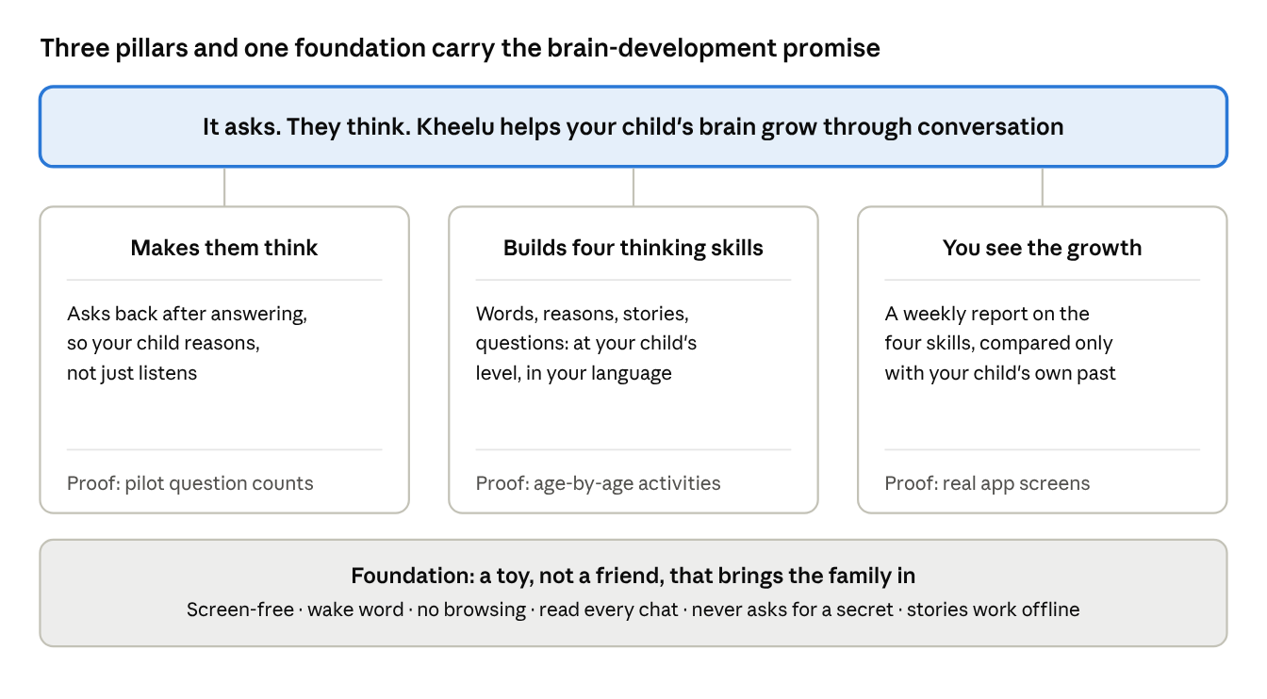
Brand pillars · 3 pillars, 1 foundation
Each pillar needs one piece of proof the team can show by launch. None is fully in place yet.
Pillar | What we claim | Why it's believable | Proof still needed
Makes them think | Kheelu asks your child questions back, so they do the thinking | Conversational turns predict language and brain activity (Romeo 2018); children understood stories better when an AI asked them questions (Xu 2022) | Pilot counts: questions asked by Kheelu and answers given per session
Builds four thinking skills | Words, reasons, stories, questions, at your child's level, in English and your home language | NEP 2020's early-years goals; the deck's age-adaptive design | Age-by-age activity list for 4, 5, 6 and 7, signed off by the advisor; language clips
You see the growth | A weekly report on the four skills, compared only with your child's own past | The deck's "10 new words learnt" update and "personal growth, not comparison" principle | Real app screenshots with the four skills
Foundation: a toy, not a friend | Safe by design, and it brings the family into the conversation | The four safety behaviours on the site; offline stories; family hand-back prompts | Data answers (audio location, retention, training); BIS date; outside safety test

Messaging
One idea everywhere: Kheelu helps your child's brain grow, because it makes them think. Everything below is that idea for a different moment.
Taglines (recommended first)
Line | Use | Note
It asks. They think. | Master line: ads, packaging, end cards | Four words. Says the mechanism and answers the AI fear in one go. Check the trademark.
Helps your child's brain grow, one conversation at a time. | Website hero, descriptor | The core promise, with the how attached
Other AI gives answers. Kheelu asks questions. | Ads, comparison table, press | Strong contrast; use as a second line
Puzzles build hands. Conversation builds thinking. | Gifting, Amazon listing | Stands Kheelu apart on the brain-development shelf
Website hero
- Headline (recommended): "Kheelu helps your child's brain grow, one conversation at a time."
- Sub-line: "A screen-free AI toy that asks your child questions, so they think, talk and wonder more."
- Short option: "The toy that makes your child think."
The current website line, "Kheelu is an AI toy built to help your child's brain grow", is close. Moving "AI toy" out of the headline means the first thing a parent reads is the outcome, not the technology. "Helps" needs the advisor's sign-off before launch.
The 20-second pitch (WhatsApp voice note, demo table)
"These early years are when a child's brain grows fastest, and research shows back-and-forth conversation is one of the best things for it. Kheelu is a soft rabbit with no screen. Your child asks it anything, in English or your home language. It answers, then asks them something back: why do you think that? What happens next? So your child does the thinking. Each week you see their new words, the questions they asked and the stories they told."
Messages by audience
Audience | Lead message | Proof to show
Mothers (main buyer) | "Twenty minutes that are good for their brain." | Pilot video of a child explaining "because…" to Kheelu
Fathers | "See how your child's thinking grows, week by week." | The weekly report screenshot
Grandparents | "Kheelu asks questions in our language, so your grandchild thinks in it too." | 20-second clip in Kannada, Tamil or Hindi
Gift buyers and corporate HR | "Give a gift that grows young minds." | Unboxing, advisor's name, 15-day returns
Preschools | "More thinking out loud for every child, with no screen in class." | Thinking Hour results
Investors and press | "Kheelona builds conversation-first brain-development products for the foundational years, starting with Kheelu." | Pilot numbers; Kheelona OS belongs here
Answers to the WhatsApp objections (90-day plan, section 2, step 4). The new one, "Won't AI make my child lazy?", will come up often now. Items in [brackets] need product confirmation.
Objection | Answer
"Won't AI make my child think less?" | "That's exactly what we designed against. Most AI gives answers. Kheelu answers, then asks your child a question back, so they do the thinking."
"Does it really help the brain?" | "Research shows back-and-forth conversation helps young children's language and thinking, and that children understood stories better when an AI asked them questions. Kheelu is built around that. Our pilot results will be published, good or bad."
"Is it safe?" | "It only listens after its wake word, it can't browse the internet, you can read every conversation, and it always says it's a toy, never asks for a secret."
"Will my child get attached?" | "Kheelu is a toy, not a friend. It ends chats by sending your child back to you, like 'Tell Amma what we found out about elephants.'"
"What happens to my child's voice and data?" | "We never sell your child's data. [Recordings kept for X days; delete any time. Voice is / is not used to train AI.]"
"Will my child use it after a week?" | "Kheelu remembers what your child has learnt, so each day builds on the last. You'll see in the report if they're still using it. If it isn't loved, 15-day returns."
"Does it speak our language?" | "Tell me your language and I'll send a 20-second clip now."
"Will it break?" | "[1-year] warranty and 15-day returns."
"Why ₹4,999?" | "It's there every day, it talks with your child in your language, and you see the progress. ₹499 reserves it, refundable until we ship."

Claims guardrails
A brain promise is only as strong as its weakest claim. One overclaim in an ad, and a parent, a journalist or ASCI files Kheelu next to "midbrain activation". Share these two tables with the designer, interns, creators and founders.
What we can and cannot say about the brain
Topic | Say this | Never say this
The core promise | "Built to support your child's brain development through conversation" / "Helps your child's brain grow" (after advisor sign-off) | "Boosts IQ", "makes your child smarter", "develops the brain 2x faster", "genius"
The early years | "NEP 2020 notes that over 85% of brain development happens by age 6" (with source) | "Don't miss the window", "your child will fall behind" (fear; ASCI bars playing on parental anxiety)
Conversation research | "Harvard research shows back-and-forth conversation helps build young children's brains. Kheelu is built around the same idea." | "Harvard-proven", "scientifically proven toy" (the studies are about conversation with caring adults, not Kheelu)
AI research | "Studies found children understood stories better when an AI asked them questions" (Xu, 2022) | "As good as a parent" (the same research found children talk more and lead more with people)
Results | Pilot numbers with the sample shown ("In our pilot of X children over Y weeks…") | Any percentage or improvement without our own data behind it
Health | Nothing | Speech delay, late talkers, ADHD, autism, therapy
Memory and emotions | "Remembers what your child has learnt and loves" | "Maps emotions and triggers", "remembers life events and values", "long-term memory"
Other words to stop using
Stop saying | Say instead | Why
"AI toy" as the headline noun | "Brain-development toy"; "AI" in the sub-line | Keeps Kheelu out of the crowded AI-toy pile
Companion, friend, best friend | "A toy that talks with your child" | The framing safety groups and new laws target
Tutor, teacher, syllabus, lessons | "Thinking skills", "learning through conversation" | Pulls us into edtech and adds pressure
"Adapts to each kid" | "Asks back", "builds on what your child learnt yesterday" | Every rival says "adapts"
"Safe" alone; "banking-grade" | The four specific safety behaviours | Specifics are believed; adjectives aren't
"Servers in India" | Only if true for the AI processing too | If audio goes to an outside AI provider abroad, the claim is false
Kheelona OS, wearables, robots | Just Kheelu | One product, one promise
Competitor brand names (including Alexa) | "Smart speaker", "robot toy with a screen" | Legal risk
Two product rules that make the promise true
- Kheelu ends most of its turns with a question, so the child talks and thinks more than the toy does.
- Kheelu regularly hands the conversation back to family. Harvard's Ying Xu found that children lead conversations more with people than with AI, so the family loop is part of the brain promise, not just a safety line.

What this changes in the 90-day plan
The plan's structure stays: WhatsApp-assisted selling, Bengaluru demos, Gate 1 on 1 November. The brain-development positioning changes what goes into each channel, and Gate 1 also decides which version of the brain message sells best.
Plan element | Change
Meta ads, weeks 2 to 3 | Test three versions of the same promise with equal budget: the mechanism ("It asks. They think."), the outcome ("Helps your child's brain grow") and the contrast ("Other AI gives answers. Kheelu asks questions."). Judge on cost per WhatsApp lead and chat-to-paid rate. The winner leads from Gate 1.
Ad creative | The first 3 seconds show a child thinking: pausing, then answering "because…". Sound on, captions on. Never the toy alone.
Child-development advisor | Put the advisor's face and name in at least one ad and on the website. A credible expert is the strongest proof for a brain claim. Chaitra (the child counsellor in the deck video) could fill this role if she agrees.
Pilot videos (week 2) | Ask each family: "What did you notice about how your child thinks or talks since Kheelu?" Capture real examples: new words, a "why" question, a retold story.
Apartment and school Story Hours | Make them Thinking Hours: Kheelu tells half a story and asks the children what happens next and why. Count how many children answered.
Instagram (organic) | A weekly "Why question of the week" series for parents, with one simple tip from the advisor. It builds authority on brain development before paid ads scale.
Creator brief | Show your child answering one of Kheelu's questions, then telling you about it at dinner. No "AI best friend" content, no brain-boost claims.
Corporate gifting | "Give a gift that grows young minds this Diwali."
Amazon listing (after BIS) | List under brain-development and educational toys, with "Puzzles build hands. Conversation builds thinking." in the first image.
Weekly numbers sheet | Add one product number: average questions Kheelu asked and answers the child gave per session among owners. It proves "It asks. They think." and headlines the raise.
Safety-scandal risk | Ready response: "Kheelu is a toy, not a companion, built for thinking. Here are the four things it never does."

Open questions and how to validate this
The direction is set; the proof is not. It needs six answers from the founders this week and two to three weeks of market tests.
Decisions for the founders this week
- ☐ Product: does Kheelu end most turns with a question today? If not, can it by launch?
- ☐ Product: can the parent app report the four thinking skills (new words, "why" and "because" answers, stories retold, questions asked)? The deck already promises "10 new words learnt".
- ☐ Advisor: name the child-development advisor and get sign-off on "helps your child's brain grow" and on the research wording.
- ☐ Age: agree to market to 4 to 7, with 3-year-olds as "with a grown-up nearby".
- ☐ Data: where does the child's audio go, including any outside AI provider; how long is it kept; is it used for training? Keep the skills report about learning progress, never emotional profiling.
- ☐ Legal: trademark check on "It asks. They think.", and a quick ASCI-style review of every brain claim before ads go live.
How to validate in two to three weeks
- Parent conversations (week 1). Ten 15-minute calls within the founder's planned learning calls. Read three one-liners aloud (the mechanism, the outcome, the contrast) and ask which one they would forward to their partner, and what they would doubt.
- Ad test (weeks 2 to 3). The three-version Meta test in the section above. Lowest cost per fully paid sale wins.
- Pilot data (weeks 2 to 4). From pilot sessions, count questions Kheelu asked and answers children gave. That turns "It asks. They think." into a hard claim: "In our pilot, children answered X questions a session."
- The AI-fear check. Track how often "Will AI make my child lazy?" comes up on WhatsApp. If often, move the contrast line into the hero.
What would make me change my mind: if parents hear "brain development" as hype in the calls, lead with the mechanism ("It asks. They think.") and keep the brain promise in the second line. The pillars and guardrails stay either way.

Sources
All pages opened 8 October 2026, plus Kheelona's research brief (30 May 2026), the Kheelona competitor review v9 (30 September 2026) and the Kheelona 90-day plan (7 October 2026).
- NEP 2020 on early childhood and brain development, EducationWorld
- Serve and return, Harvard Center on the Developing Child
- Romeo et al. 2018 on conversational turns, LENA summary
- Ying Xu, "Different but complementary", Joan Ganz Cooney Center (Oct 2024), citing Xu et al. 2022, Child Development
- Lazaroff & Vlach 2022 on children's questions (cites Chouinard 2007), Frontiers in Psychology
- Is it time to measure cognitive stunting? Brookings (May 2026)
- ASCI education advertising guidelines press release (Mar 2023)
- ASCI Code
- Midbrain activation, Wikipedia
- Brain development toys buying guide, MagicDrop (Jul 2026)
- AIIMS Raipur meta-analysis on under-5 screen time, Pune Pulse (Jan 2026)
- Common Sense Media advisory on AI companion toys, via KQED (Jan 2026)
- California SB 867 and SB 1119 signed, Toy Association (Sep 2026)
- MyWonder home page
- Miko Mini product page
- Scoobies Pookie page (from the competitor review)

